Chapter – 3

Induction motor

Because of its simple construction, rugged in nature, reliable, inexpensive and reasonably efficient the induction motors consume the most of the electric power. Even though the induction generators are not at all popular but the share of induction motors is almost 85% of the total motors used in industry.

3.1 Principle of operation

The principle of operation of induction motors can be easily explained with the help of Fig. 1. It is seen in Fig. 1 that a short-circuited coil of having ‘n’ number of turns is placed in a magnetic field which is rotating at a speed ω₁. Because of the movement of the flux there will be a change of flux-linkage in the coil resulting in an induced emf in the coil which is obtained from Fleming’s right-hand rule and is given by
E = Blvn = nBlrω₁ [V].
Now as the coil is short-circuited the induced emf will circulate a current decided by the short-circuited impedance of the coil. This coil carrying this short-circuited current being in the magnetic field will experience a torque, the force is given by Fleming’s left-hand rule. Due to this torque the coil will also rotate. The direction of rotation of the coil is obtained from Lenz’s law which will try to oppose the cause because of which it is due. Since the very cause is the rotation of the field, the coil will rotate in such a direction so that the relative speed between them becomes zero. Or in other words, the coil will follow the magnetic field. Now if the speed of the coil becomes same to that of the speed of the field, ω₁, the relative speed between them will be zero and there won’t be any induced emf in the coil. So there won’t be any torque. So in order to maintain the rotation of the coil, the speed of the coil will be slightly less than the speed of the field. If the coil rotates at a speed ω₂, the relative speed between the field and the coil is ω₁-ω₂. This relative speed is responsible for the development of induced emf and the necessary torque for the operation of the motor.

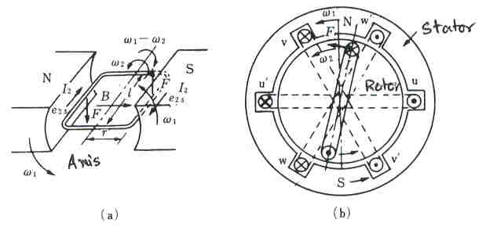

Fig. 1 Principle of operation of induction motor

3.2 Construction of induction motors

The induction motor has two parts: the stator and the rotor. The stator of the induction motor is exactly similar to that of synchronous motor. It has a three-phase distributed winding. While three-phase balanced voltage is applied to the stator winding, a constant magnitude rotating magnetomotive force is produced.
The construction of the rotor can be of two types: slip-ring and cage-rotor. The slip ring type is shown in Fig. 2. It has got three phase winding distributed along the rotor periphery. The terminals of the windings are connected to the slip rings placed on the shaft. The additional resistances are connected to the slip rings and then shorted. The additional winding can be used for the starting as well as speed control.
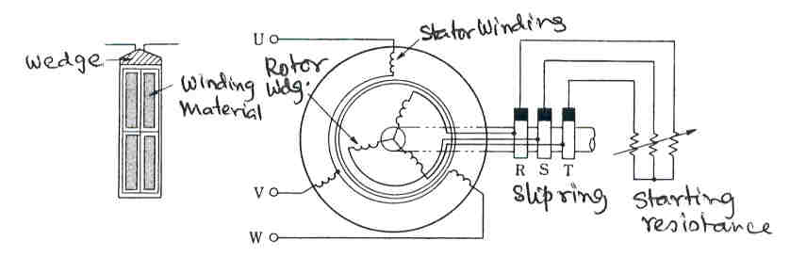

Fig. 2 Rotor of the slip-ring induction motor

The rotor of squirrel cage induction motor(SQIM) carries a squirrel cage winding consisting of number of conductors whose ends are short circuited by a copper or aluminum ring as shown in Fig. 3a. Different types of slot can be fabricated for various performances, a few of which are shown in Fig. 3b.
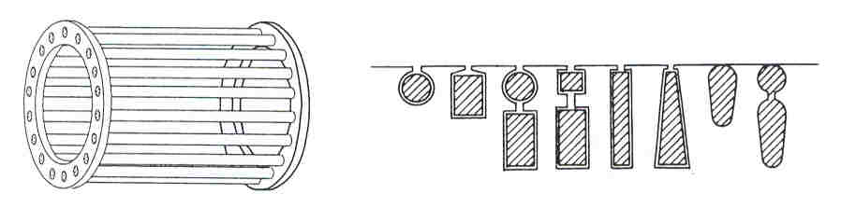
Fig. 3a Rotor of SQIM Fig. 3b Different type of rotor slots of SQIM

3.3 Analysis of IM, Slip

The analysis of induction motor can be carried out in a similar way to that of a transformer. When a three-phase balanced voltage is applied to the stator winding a rotating mmf is generated. Because of that a back emf will be induced in the stator winding. The per phase value of the induced emf is given by
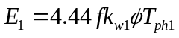 where k_{w1} is the winding factor of the stator.

If the rotor is assumed stationary like transformer the induced emf of the rotor can be written as
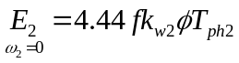
We have seen earlier that the rotor will run at a speed of ω₂.
The relationship between the speed of the rotating mmf and the supply frequency is given by the following equation.
Let N be the speed in rps
The angular speed ω₁ is given by ω₁ = 2 π N
The speed, N, the frequency, f₁ and the pole of the machines is related by f₁ = (PN)/2 which gives N = 2f₁/P
So we get
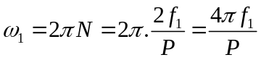

Slip: It has been explained earlier that the rotor cannot run at ω₁. The slip denoted by s is defined as 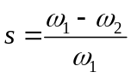.
While the rotor is running at a speed ω₂, the relative speed of the stator magnetic field and the rotor is ω₁-ω₂. So the frequency of the induced emf of the rotor winding is proportional to (ω₁-ω₂).
The frequency of the induced emf of the rotor winding is given by
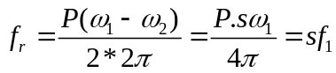
It is seen that the frequency of rotor induced emf is sf₁.

While the rotor speed ω₂ is zero, we have s= (ω₁-0)/ω₁ = 1.

If the rotor speed ω₂ becomes equal to ω₁, the slip, s becomes 0. So the slip is a parameter varies from 1 to 0.
Since the rotor winding has a frequency equal to that of sf₁, the equation of the induced emf is given by 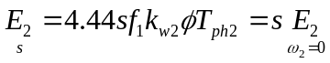.

Since the rotor is short-circuited, the per phase equivalent circuit of the rotor can be represented as shown in Fig. 4.
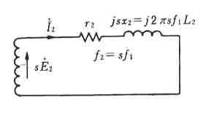

Fig. 4 Equivalent circuit of the rotor

The equivalent reactance of the rotor x₂ = 2πfL₂ is modified for a slip, s, as sx₂. The impedance of the circuit is
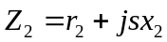
The current in the rotor circuit is given by
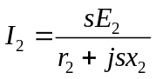.
The magnitude is given by 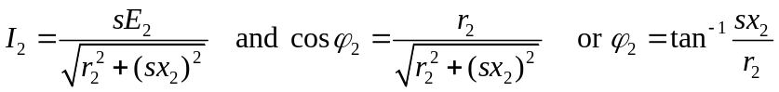
Where 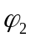 is the angle between sE₂ and I₂.

The current in the stator circuit can be calculated as follows. Because of the current in the rotor circuit there will be a compensating current in the stator circuit will balance the mmf of the rotor circuit. With the help of a general equation it can be expressed as
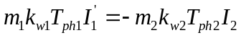 where m₁ and m₂ are the phases of stator and rotor respectively.
Under no-load condition a current flows in the stator known as no-load current. A part of which is required to generate the air-gap flux and is known as magnetizing current. The magnetizing current is usually in phase with the air-gap flux. Another component of current which is required to supply the losses such as copper loss in the stator resistance and the core loss in the stator core is known as loss-component of current. The total stator current is the vector addition of these currents.
The vector diagram of the induction motor is shown in Fig. 5.
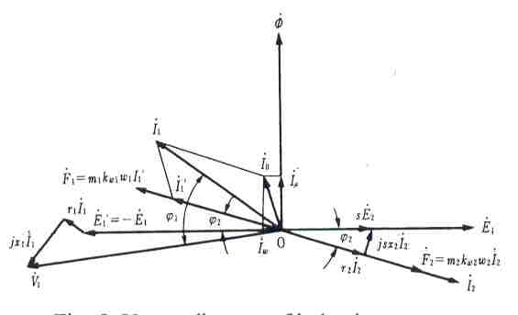
Fig. 5 Vector diagram of induction motor
  - Equivalent circuit of IM

For the simplified analysis of the performance of induction motor it is necessary to develop the equivalent circuit. The slip-ring induction motor has got three phase winding in the rotor. So the analysis is much easier to visualize. Since the SQIM has got the rotor bars it is difficult to assume how many phase are there in the rotor winding. The rotor winding can be considered as consisting of m₂ phases as shown in Fig. 6. The stator winding has got three phases, so m₁ = 3. The equivalent circuit for this can be represented as shown in Fig. 7. The induced emf for the each and every phases of the rotor winding is assumed to be at slip frequency.
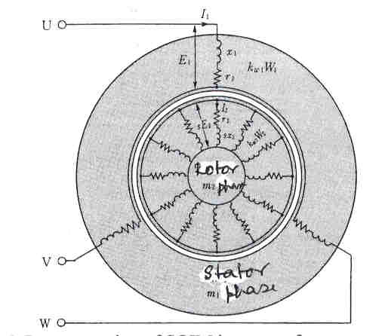

Fig. 6 Representation of SQIM in terms of parameters

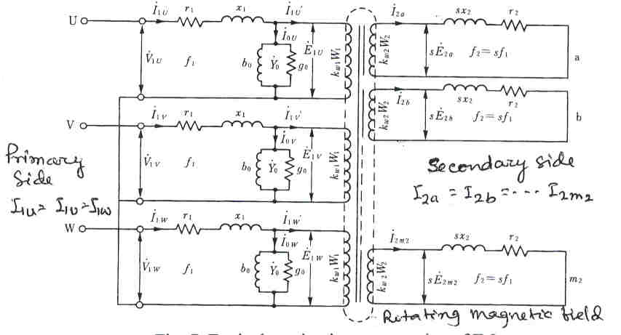

Fig. 7 Equivalent circuit representation of IM

In order to simplify the calculation the parameters in the rotor circuit is brought o the stator side. In transformers this was done by taking into account the turns ratio of two sides. In induction motors not only the turns ratio but also the operating frequency for the stator and rotor side is different. The difference in turns ratio can be taken into account just like transformer. The difference in frequency or the induced emf of the rotor circuit at slip frequency, sf₁, while represented in the stator side, the emf should correspond to supply frequency f₁. This is done in the way as shown in Fig. 8.

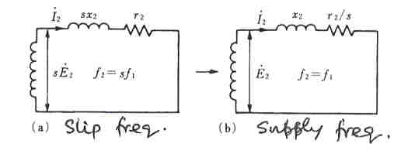

Fig. 8 Transformation of rotor parameters of IM

The current in the rotor circuit is given by,

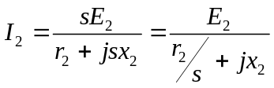
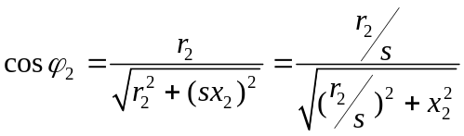

Based on this transformation the equivalent circuit can be represented as shown in Fig. 9.

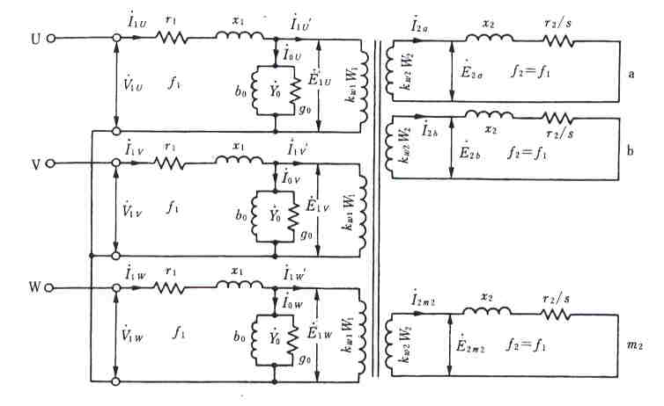

Fig. 9 Equivalent circuit of IM

Assuming three phase of the stator side is perfectly balanced as well as the rotor side. Then the complete analysis can be achieved by doing the calculation for only one phase. The equivalent circuit under this condition is shown in Fig. 10. This is based on the fact that total air-gap power for the stator side is exactly equal to that of rotor side i.e., P_{a1}=P_{a2}.
Now 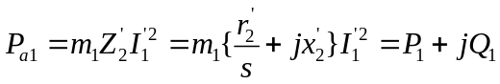
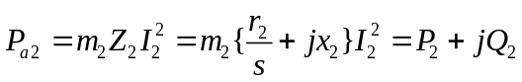
As P₁ = P₂, we can write 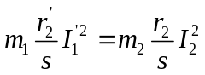 from which we get 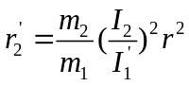.
From the mmf balancing of stator and rotor winding, we get
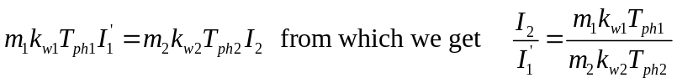.
So the referred resistance r₂’ can be written as
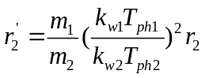.

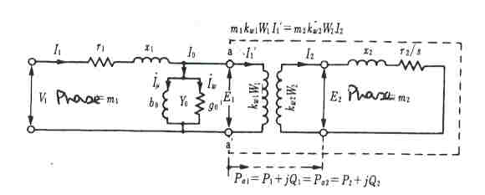

Fig. 10 Equivalent circuit representation in per phase basis

Similary by applying Q1 = Q2, we get
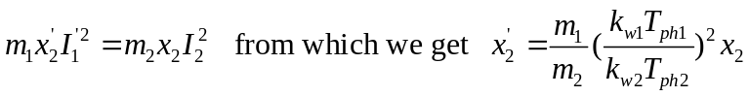.
Since the rotor side parameters has now been referred to the stator side the equivalent circuit can be shown as in Fig. 11 in which all the parameters has been represented in the stator side.

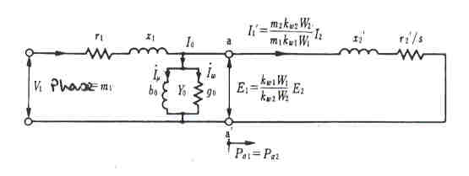

Fig. 11 Equivalent circuit with all parameters in stator side

There will be little error in the calculation but the calculation will be very much simplified if the no-load parameters are brought to the input side as shown in Fig. 12 which is known as approximate equivalent circuit of induction motor.

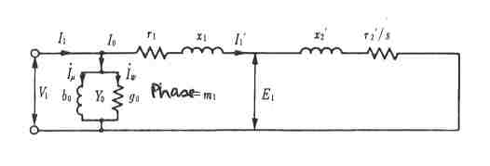

Fig. 12 Approximate equivalent circuit of induction motor

3.5 Performance calculation of IM

The performance of IM are calculated as follows.

The total power transferred to the rotor side is given by
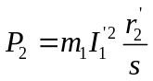
ut of this power a part is lost in the rotor resistance P_{cu2} =m₁I₁^{’2}r₂’ and the rest power is the develped power, P_{d}.

So the developed power is given by
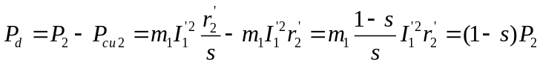.

From Fig. 12, we can write the following equations

The input power P₁ = m₁ V₁ I₁ cos 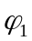

The core loss P_{core} = m₁ V₁ I_{w}

The stator copper loss P_{cu1} = m₁ I₁^{’2} r₁

The rotor power or air-gap power P₂ = m₁ I₁^{’2} r₂’/s

The rotor copper loss P_{cu2} = m₁ I₁^{’2} r₂’ = sP₂

Developed power P_{d} = (1-s)P₂

Actual output power P_{o} = P_{d} – mechanical losses

The developed torque of the motor is given by
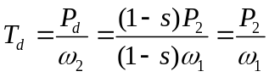

3.6 Torque-speed characteristics of IM

From Fig. 12 the current I₁’ is given by
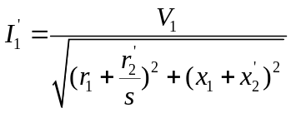
The developed torque is given by 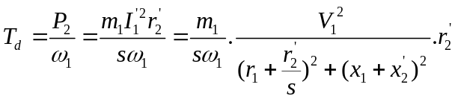
Assuming X=x₁ +x₂, and neglecting the stator resistance, the approximate expression for the torque is given by,
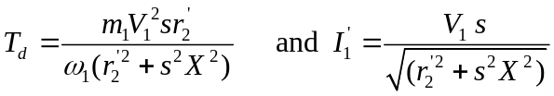
The variations of current and developed torque as a function of slip are Fig. 13.

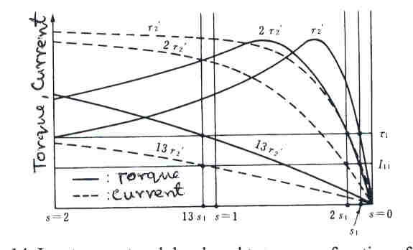

Fig. 13 Input current and developed torque as a function of slip

  - Starting of IM

While the power is switched on to start induction motor, it draws a large amount of current from the supply system. In order to restrict the starting current there are different methods used to start IM.
- Direct On Line (DOL) starting : This is used for low rated motor and the power is applied directly to start the motor.
- Stator impedance method: To reduce the voltage drop across the motor a impedance is connected in series with the motor. The impedance is made out of the circuit when the speed of the motor is close to full load speed.
- Auto-transformer method: To apply less voltage across the motor terminals an auto-transformer is used.
- Star-delta method: The motor winding initially is connected in star and the power is applied to the motor. Once the speed becomes high the winding is connected to delta. In this method it is possible to reduce the line current to one third compared to delta connected starting.
At starting s= 1.
The starting current is given by 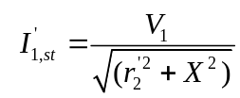
And the corresponding torque,
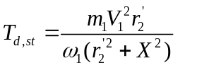

From the earlier expression of torque it is seen that the torque is a function of the slip. The maximum value of torque can be obtained by making dT_{d}/ds = 0, which gives the conditon r₂’ = s_{m}X. The silp at maximum torque is defined as s_{m}.

3.8 Speed control of IM

The induction motor is usually considered as a constant speed motor. But in industrial application it is required to run the machine as variable speed. Earlier different methods were used to change the voltage across the terminal, to change the operating frequency. Now-a-days power electronic based systems are used for the control of speed of induction motors. Fig. 14 shows a transistor based inverter used for the speed control of induction motor. Usually three phase input voltage is used and is rectified to feed power to the inverter. Different sensors such as speed, current etc are used for the control purposes. Usually a sophisticated controller such as microprocessor or digital signal processors are used for the implementation of the control algorithm.

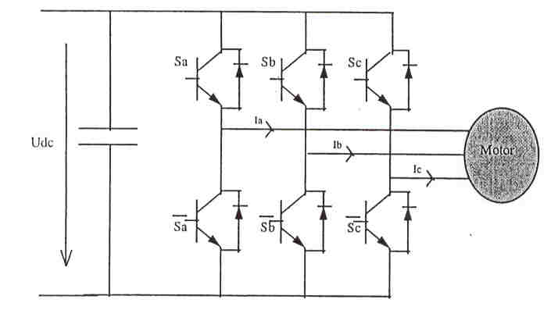

Fig. 14 A transistor based three-phase inverted for induction motor speed control

